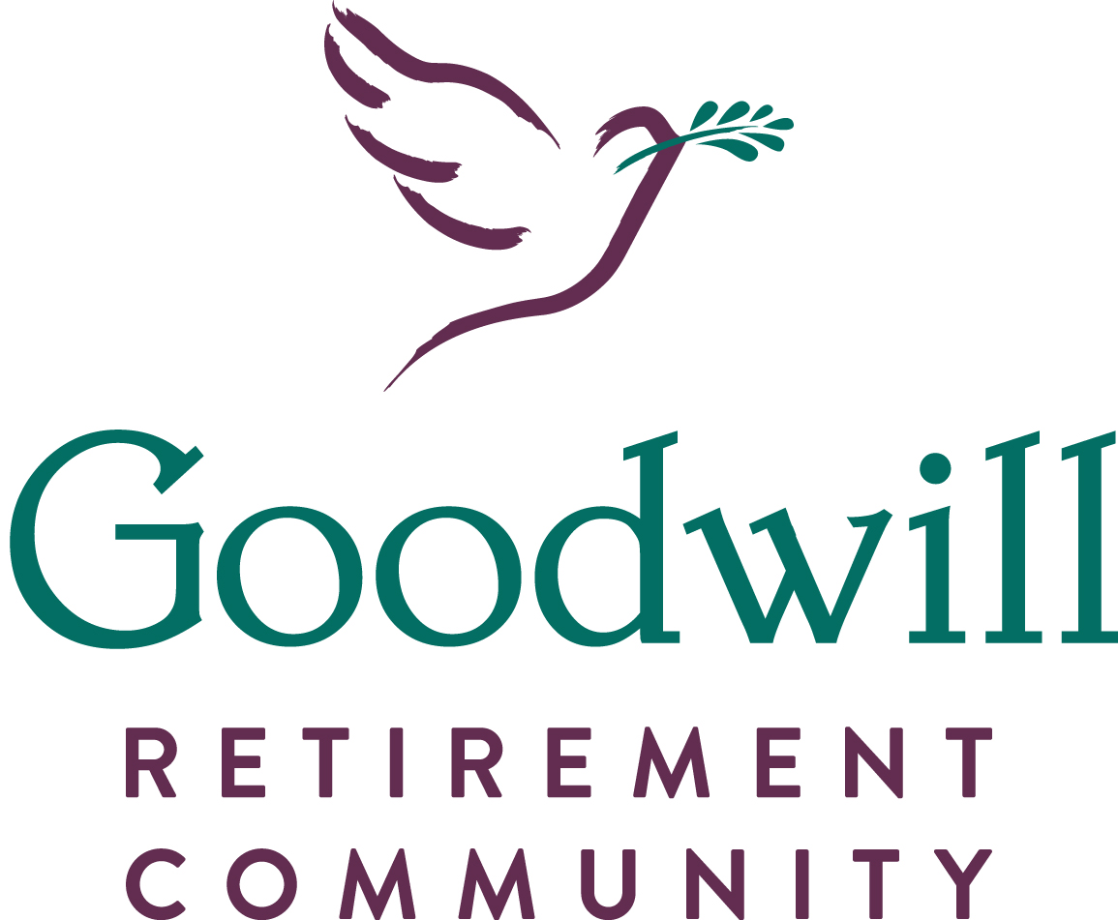
Resident Handbook

Goodwill Mennonite Home, Inc.
891 Dorsey Hotel Road
Grantsville, MD 21536

Goodwill Mennonite Home

Resident Handbook

The staff and residents of Goodwill Mennonite Home welcome you as a resident. We want to help you adjust to your new home and will work to make your life here as pleasant as possible. The following tells you a little bit about life at Goodwill. If you have questions that are not answered in this booklet, please let any staff person know and they will be happy to help you.

General Information
You may have some questions about your new home. Here are answers to some questions that are frequently asked by residents.

May I Have Visitors? This is your home! You may welcome visitors to your home at any reasonable time. However, the best times for visitors are after 10AM and before 8PM. You have the right to select the visitors you wish to see.

May I Make Suggestions For Improvement? We welcome any ideas you have that you feel would make an improvement in resident care or operations. Please share them with us!

May I Bring Personal Items For My Room? You may bring personal items for your room, but you must have enough room to get around safely and easily. You may bring a favorite chair, pictures, and a radio for example, but Goodwill does have a “No Hole” policy which does not permit nails, screws, etc… to be used to secure items to walls. Instead, resident supplied removable adhesive fasteners designed to protect the wall finish may be utilized to secure items to walls. Tape may not be used on wall surfaces. No items may be secured to or hung from doors other than an approved decorative wreath hung from a resident supplied removable adhesive fastener designed to protect the door finish.
We label your personal clothing items to prevent them from being misplaced. There is a small charge for this service.

May I Move To A Different Room? If, for some reason, you would like a different room, or if you find that you and your roommate are incompatible, you may request to be moved to a different room. You may do this by telling the Director of Nursing, Administrator, or Social Services.

Will You Hold My Room If I Am Temporarily Away? If it should be necessary for you to be hospitalized, or if you would like to leave for a few days, you can make arrangements to hold your bed at the current daily rate. If you choose to not hold your bed, you will be discharged and your bed made available to another admission. Then, when you are ready to return, you will be admitted to the next available bed.

May I Share A Room With My Spouse? You and your spouse are permitted to share the same room if the physician and both of you agree to it and if the room has a private bathroom. When husband and wife share the same room, neither may interfere with the nursing care given to the other.

May I Use A Television (TV) Set And/Or A Radio? Yes, a TV set is provided but you may provide your own radio. There is a hook-up charge for cable television and a monthly fee for the cable television service. There is no charge for radio. The volume of television and radio sets must be regulated so as not to disturb other residents. We suggest that you use headphones if you need the volume very loud. You may use the television set in any of the day rooms free of charge.

When Are Meals Served? Meal trays are delivered between:

BREAKFAST: 7:20 a.m. and 8:05 a.m.
DINNER: 11:45 a.m. and 12:35 p.m.
SUPPER: 5:20 p.m. and 6:00 p.m.

We serve breakfast to you in your room. We encourage all residents who are able to do so to come to the Dining Room for the other meals.

The Dietary Services Department is interested in knowing what your likes and dislikes are. If you do not like certain items on the menu, Dietary Services staff members will try to substitute something you do like instead. We serve you snacks at bedtime. We will also serve you snacks upon your request at other times as appropriate.

May My Family Members Or Friends Bring Food For Me? We ask people who bring in food for you to have the food items approved by the Charge Nurse because your physician may have ordered a special diet for you. We serve bedtime snacks to residents.

May I Take Care Of My Own Finances? Residents who are capable may take care of their own finances. We will assist you if you so request in writing.

Where Do I keep My Money And Valuables? We ask that you not keep large sums of money or valuable jewelry in your room. You may ask us to keep these items in a safe and secure place in the office. We will give you a receipt for them and return them any time you want them.

What Should I Do If I Begin To Run Out Of Money? If you run out of money, you may be eligible for Medical Assistance. The Administration office will answer your questions and help you to apply for Medical Assistance.

May I Help In Planning For My Care? We review your care plan on a regular basis. You have a right to take part in this review. You are not required to do so, but we encourage you or a family member you delegate to help us with this planning. The MDS Coordinator will tell you when we will review your care.

May I Participate In The Activities Program? The Activity Staff plans an activity for residents each day. You are not required to attend these functions, but we strongly encourage you to attend them and to take part in them. If you have a favorite activity, the Activities staff will help you with the activity if possible.

What Should I Do If I Suspect That I Am Being Abused Or That I Am Not Being Permitted To Exercise My Rights? If you feel you have been abused by a staff member, or if you feel that you are not permitted to exercise your rights in some way, you should report this to the Administrator. Staff members are not permitted to hit or verbally abuse residents. Residents are not permitted to hit or verbally abuse other residents or staff members. You must report any such actions immediately. If you have any such problems, please report them to the Charge Nurse, the Director of Nursing, or the Administrator so we can correct the situation.

How Can I Get Spiritual Counseling? If you would like someone to counsel with you, you may ask to counsel with the Chaplain on our staff. If you have a pastor, we notify your pastor that you are living here. We will notify the pastor when you would like to see him or her.

May I Smoke Here? We maintain a tobacco free environment. There are no areas in Goodwill Mennonite Home that are designated smoking areas.

CHARGES FOR YOUR SERVICES: PRIVATE PAY
We bill on or about the twenty-fifth day of the month for all extra charges not previously billed and for your per diem (daily charges) for the coming month. These charges are due to be paid on the first day of the month. If they are not paid on or before the first day of the month, the amount becomes past due. If you do not pay your past due amount within thirty days, we will charge you one and half percent interest per annum on the unpaid amount. We will bill your Medicare insurance as appropriate for the services we provide for you. You must pay the difference between our charges and what Medicare pays. If you have private insurance, you will pay Goodwill for all charges and submit your bills to the insurance company yourself. Charges for services fall into two categories: per diem (daily) charges and charges not included in the per diem rate.

Per Diem Charges
The per diem rate includes charges for your room; meals, including special diets and snacks; linens, including under pads; laundry and housekeeping services; nursing care; the use of a cane, walker, wheelchair, social services; and scheduled activities and entertainment. The cost of each of these services is included in the per diem rate. The per diem rates are listed below. (Rates effective January 1st, 2021)

GOODWILL MENNONITE HOME
Per Diem Rate Schedule for Services

Level of Nursing Care Semiprivate Private
Light Care $280.00 $293.00
Moderate Care $322.00 $335.00

Heavy Care $354.00 $367.00

Charges Not Included In The Per Diem Rate
Charges for the following services provided by Goodwill are not included in the per diem rate. We will add the cost of the services to your monthly statement as you use them.

Visits To You By Your Attending Physician: Your attending physician will bill Medicare or Medical Assistance as appropriate for your services. Otherwise, he or she will bill you directly for regular and emergency visits for your care. The physicians who provide care at GMH are:

Dr. Naeem
Dr. Miller
Dr. Tuel
Dr. Bissell

Medications: The pharmacist will bill Medicare and Medicaid for medications ordered by the Physician as appropriate; otherwise, we will bill you for your medications and medical supplies needed for special care.

Treatment Supplies: Treatment supplies are supplies that are: 1) Ordered by a Physician, 2) Patient Specific, and 3) Non-reusable.

Therapy Services: We will bill Medicare as appropriate for your physical therapy, occupational therapy, and speech therapy services as prescribed by your physician.

Dental Services: : Goodwill Mennonite Home has an agreement with Dr. Holly Sisler, DDS, to provide dental services for any resident of the Home who does not have a personal dentist. Dr. Sisler is a local dentist with an office in Grantsville. She will bill dental insurance for your dental services as appropriate; otherwise, she will bill you directly for her services.

Holly Sisler, DDS
Grantsville Family Dentistry - (301) 895-8076

Other dentists are located in the surrounding communities.

Podiatrist: A Podiatrist makes regular visits to Goodwill Mennonite Home to provide services ordered by the Physician. The Podiatrist bills Medicare as appropriate; otherwise, he or she will bill you for his or her services.

Vision Care: Your vision care specialist will bill Medical Assistance as appropriate; otherwise, he or she will bill you directly for vision care services.

Beautician: The services of a Beautician are provided for the convenience of the residents. Charges are included on your Goodwill statement. The following rates apply:
Haircut ..………………$18.00
Shampoo & Set……….$19.00
Shampoo, Cut & Set….$28.00

Permanent…………….$55.00

Barber: A barber provides haircuts for men. Charges are included on your Goodwill statement. The following rate applies:
Haircut………………..$17.00

Name Tags: We apply nametags to the resident’s clothing at admission and whenever additional clothing is provided. We charge $11.00 for this service on your Goodwill statement.

Transportation: If you are transported to the hospital by the Rescue Squad, the Rescue Squad may be able to bill Medicare for that service. If we transport you by Goodwill vehicle, we charge you at the following rates*:
Accident……………...$64.00
Grantsville……………$22.00
Cumberland…………..$96.00
Frostburg……………..$65.00
Meyersdale…………...$64.00
Oakland………………$115.00
*Rates may change for holiday trips

The above rates include a driver, vehicle, travel time, and one (1) hour at the destination. An additional charge of $5.00 will be made for each additional 1/4th hour at the destination. If an aide is required to go on the trip, a charge of $5.00 will be made for each 1/4th hour of the aide's time.

TV Service: Television service is available. There is a one-time activation charge of $15.00 and a monthly service rental fee of $15.00. A TV set is provided. There are TV sets in the day rooms for you to use at no charge.
Refrigerator: You may choose to provide your own refrigerator in your room. Refrigerators that residents/responsible parties wish to maintain as their own in their own room will be subject to the following:
- The refrigerator size is limited to two (2) cubic feet or less;
- The resident/responsible party will be responsible for maintaining temperatures, cleaning and food removal of the refrigerator including:
  - Food/drinks will be stored in original packaging or divided into single serving containers;
  - All food/drinks not in original packaging cannot be stored for longer than 3 days;
  - All food/drinks will be marked with an open date or (if not in original packaging) a date placed in refrigerator;
  - Expiration dates, when applicable, will be followed;
  - Refrigerator temperatures will be maintained within the range of >34 degrees and <44 degrees; and
- The additional cost of five ($5) dollars per month will be charged to the resident.

Please note that Goodwill maintains refrigerator storage for residents and at no additional cost to the resident at or near the nursing stations. Also note that Medicaid will not pay for the additional cost of a refrigerator in a resident’s room for their own use.

Telephone: We provide a telephone outlet in each room. You or your family may contact the business office at Goodwill Mennonite Home to make all the necessary arrangements to have a phone installed there at your expense. The business office will bill you directly for the installation charge and for all monthly charges. There is a one-time activation charge of $20.00. For additional pricing information on monthly calling plans, please refer to your contract. Other telephones are accessible to you at various places in the halls. Staff members will assist you in placing calls. You report long distance phone calls on the honor system, and we will add their cost to your monthly statement.

Wi-Fi: Hi-speed Wi-Fi internet access is available to residents. You will need to have your own computer with a Wi-Fi connection.

MEDICAL ASSISTANCE PROGRAM

Qualifying For Medical Assistance
If the funds for your care are depleted you may be eligible for Medical Assistance. The Administration office will answer your questions and assist you in applying for Medical Assistance. The following information will help you understand Medical Assistance.

Covered Charges
Medical Assistance covers the cost of your care in a semi-private room including your room; meals, including special diets; linens, including under pads; laundry and housekeeping services; nursing care; routine nursing supplies; routine dressings; some hygiene supplies; the use of a cane, walker, wheelchair, or pressure mattress as required; therapies as ordered by the attending physician; social services; and scheduled activities and entertainment.

Charges Not Covered
Examples of items not covered by Medical Assistance:
- a private room
- television services
- beautician or barber services
- telephone and Wi-Fi services
- transportation services
- name tags

